VPC Endpoints

- An endpoint can be IP address or DNS or URL, which is used to connect/communicate with other AWS services or on-premises devices. (No internet access required )
- VPC (Virtual Private Cloud) Endpoints allow you to privately connect your VPC to supported AWS services.
- VPC endpoint services powered by AWS PrivateLink.
- They enable communication between your VPC and AWS services without requiring an internet gateway, NAT device, VPN connection, or AWS Direct Connect.
Types of VPC endpoints:
- Interface endpoint.
- Gateway endpoint.

- Interface Endpoint:
- Definition: An Elastic Network Interface (ENI) with a private IP in your subnet.
- Used For: Most AWS services like S3 (optional), CloudWatch, SNS, SQS, etc.
- Connectivity: Powered by AWS PrivateLink.
- Billing: Charges apply based on usage and hours.
- Example Services:
✔️ SSM (AWS Systems Manager)
✔️ CloudWatch
✔️ STS (Security Token Service)
✔️ SNS, SQS, API Gateway, etc.
- Gateway Endpoint:
- Definition: You configure a route in your VPC's route table that directs traffic for the supported service (S3 or DynamoDB) through the gateway endpoint.
- Used For: Amazon S3, DynamoDB.
- Connectivity: Does not use AWS PrivateLink.
- Billing: Free of charge (no hourly usage fee).

Features:
- Private connectivity: Traffic stays within the AWS network (Avoid exposure to the public internet.).
- Access Control: Use IAM policies and VPC endpoint policies for fine-grained access control.
- Security Groups: You can associate security groups with Interface Endpoints to control inbound and outbound traffic.
- Improved Performance: Reduce latency by avoiding the public internet (Lower latency by routing traffic through AWS internal network.).
- Cost Reduction: Avoids extra charges by not sending data over the public internet. (No band width charges, NAT gateway data processing charge). That means it works without IGW, NAT or VPN.
- Simplified Architecture: VPC endpoints simplify your network architecture by reducing the need for Internet Gateways, NAT devices, or VPN connections for accessing specific AWS services.

Feature | Description
Private Connectivity | Connect to AWS services without public internet.
Access Control | Use IAM and endpoint policies for permissions.
High Availability | VPC endpoints are redundant within an AZ.
No Internet Gateway Required | Works without IGW, NAT, or VPN.
Logging Support | Integration with VPC Flow Logs for monitoring.

SSM (AWS System manager):
Interface Endpoint is used for the SSM (AWS system manager), This SSM a full management and automation service in AWS.
It gives you a unified interface to view operational data from multiple AWS services and automate operational tasks across your AWS resources, including EC2 instances, on-premises servers, and virtual machines in hybrid and multi-cloud environments.
AWS Systems Manager is a management service that helps you:
- View and control infrastructure on AWS and on-premises.
- Automate operational tasks.
- Run commands, patch systems, collect logs, manage configurations, etc.
Key Features:
- Run Command
- Patch Manager
- State Manager
- Parameter Store
- Automation
- Inventory
- Session Manager

Session manager:
- Session manager is a part/sub-feature of SSM.
- It mainly used to connect to EC2 instances or other managed instances securely. (Instead of exposing to internet like using ports, SSH, and bastion).
- We can connect to EC2 instances, edge devices, on-premises servers, and virtual machines (VMs) without the need to open inbound ports, maintain bastion hosts, or manage SSH keys (Linux) & RDP (Windows).
- Session manager uses browser (AWS Console) or CLI to connect securely to the EC2 instances.
- This session manager is depends on the SSM agent.
- SSM Agent is a lightweight software installed on an Amazon EC2 instance, on-premises server, or virtual machine that enables AWS Systems Manager (SSM) to communicate with that instance.

Scenario:
Whenever we lost the .ppk or .pem key which is used to login or connect to EC2 instance from our local machine, we use the Session manager to connect to EC2 instance. And then we can regenerate the new key-pair.

SSM Agent:
The SSM Agent acts as a bridge between:
- Your instance (EC2, on-premises)
- And AWS Systems Manager service (AWS)
It allows AWS to execute commands, send/receive data, and manage configurations on the instance.

When you use Session Manager, the SSM Agent plays a critical role:
Role | Description
Secure Tunnel | Establishes a secure channel between AWS and your EC2 instance.
Communication | Listens for Session Manager requests and initiates connection to AWS Systems Manager.
No SSH Required | Replaces SSH by using the agent + IAM credentials (no need for port 22 or key pairs).
Data Streaming | Streams terminal session data securely between instance and AWS Console/CLI.
Logging Support | Sends session logs to S3 or CloudWatch if configured.

Note: To allow EC2 instances to interact with AWS Systems Manager (SSM) — including Session Manager — you must attach an IAM Role to the instance that grants the necessary permissions.
The role name is “AmazonSSMManagedInstanceCore (AWS managed policy).
This is an AWS-managed IAM policy that provides the minimum required permissions for an EC2 instance to:
- Use Session Manager
- Run SSM commands
- Access SSM parameters
- Connect to the SSM service endpoints.

Let us work with the Session manager (uses interface endpoint) which is part of SSM practically.
Block Diagram:
AWS Cloud
VPC
SSM
EC2
EC2
Private-Subnet
Public-Subnet
SSM-Message
EC2-Message
Session manager
SSM
SSM-Message
EC2-Message

Fig: Connecting to the EC2 instances using VPC endpoint (Interface endpoint) to session manager.

To establish the connection between the EC2 instances and session manager, first we have to create & configure the three main Endpoints they are:
- SSM (com.amazonaws.us-east-2.ssm),
- SSM-message (com.amazonaws.us-east-2.ssmmessages), and
- EC2-message (com.amazonaws.us-east-2.ec2messages) Endpoints.
These Endpoints are used to connect the EC2 instance securely, using AWS internal network instead of exposing it to the public-internet, using session manager.
Let’s perform the above block diagram task

Step1: Create the VPC with two subnet (Public & private) with in it.
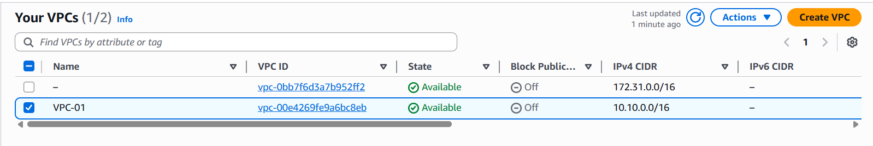
Fig: VPC is created.

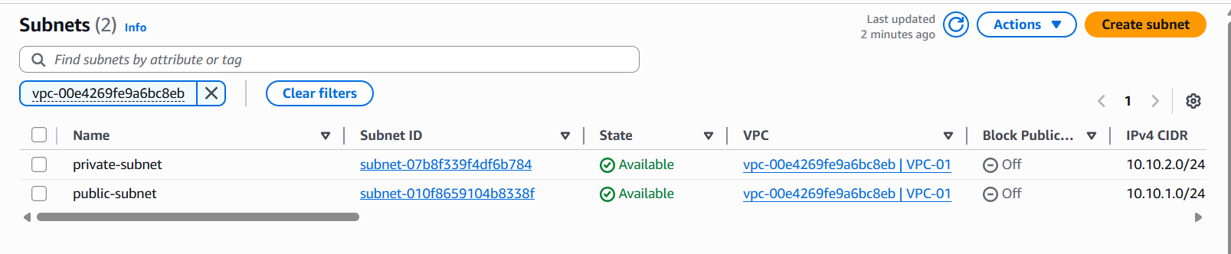
Fig: Two subnets (private & public) are created.

Note: A subnet is send to be private when it is attached to the Route table (RT) in which no routing rule to the IGW.
Here we create two RT’s one is for public-subnet and other is for private-subnet, The RT which is assigned to private-subnet have no routing rule for IGW, and the RT which is assigned to the public-subnet has routing rule for to the IGW.

Step2: Create an IAM role in order to connect the EC2 instance with session manager.
Go ToIAMRoles create a roleAWS service EC2 (service or use case)Next AmazonSSMFullAccess & AmazonSSMManagedInstanceCore (select policy’s)Next Role namecreate role.
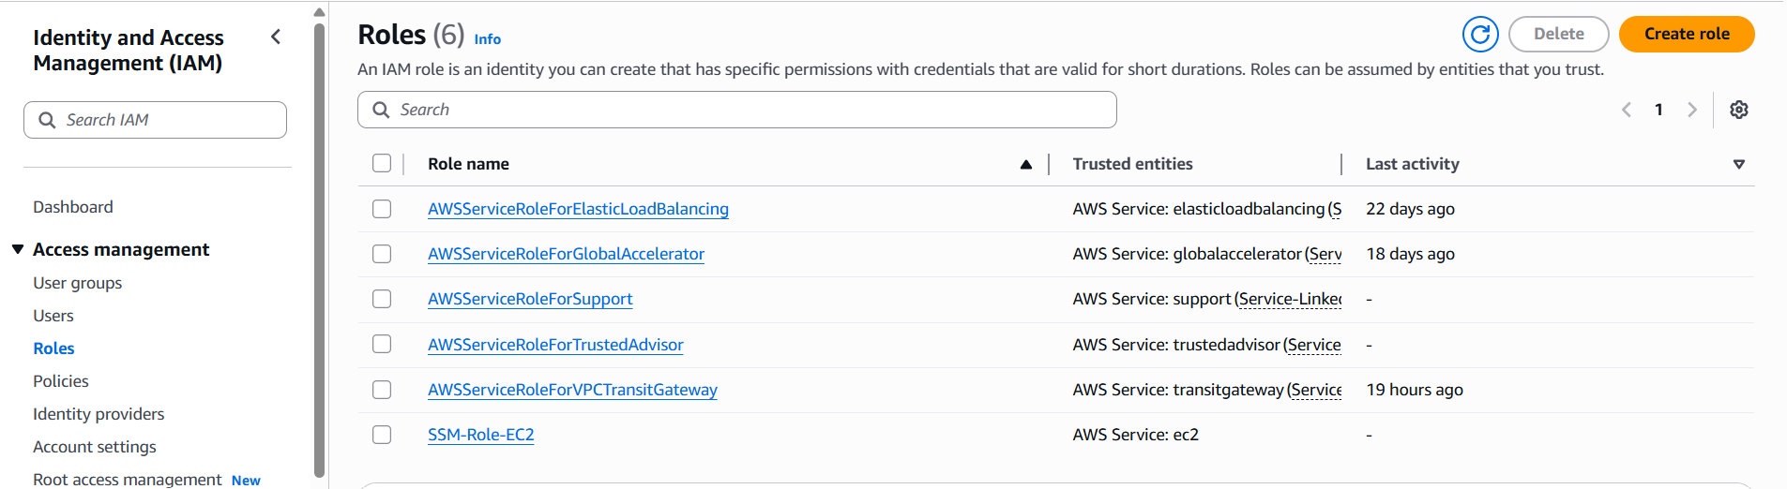
Fig: IAM Role (SSM-Role-EC2) is created to enable the access for SSM & session manager.

Because Session Manager (part of AWS Systems Manager) needs permission to perform actions on the EC2 instance, and in AWS, permissions are managed using IAM roles.
- Session Manager doesn't use SSH keys or bastion hosts.
- Instead, it uses the SSM Agent on the EC2 instance, which must authenticate and communicate with the Systems Manager service.
- IAM roles provide the required security credentials for that communication.
Step3: Create the EC2 instances in private & public subnets by adding this IAM role while creating it.
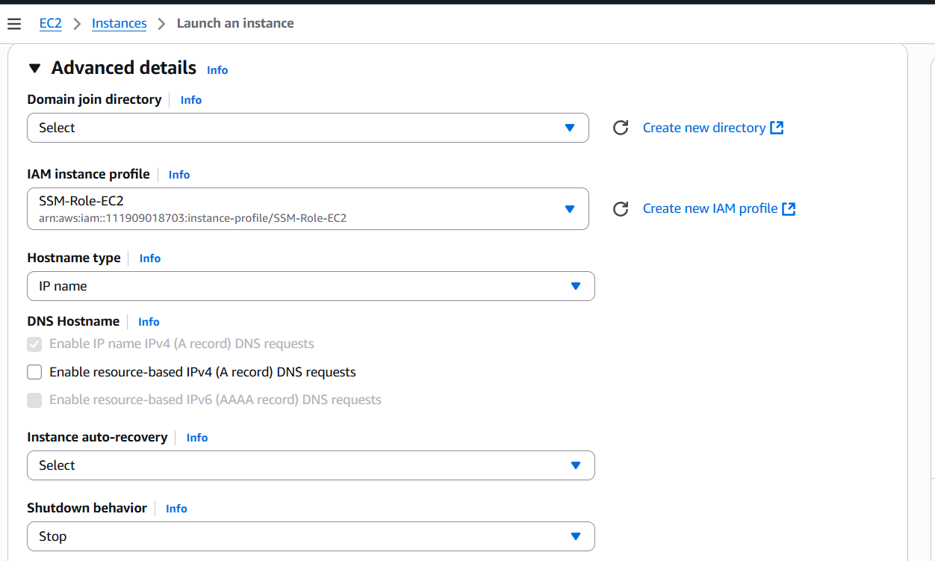
Fig: Adding of IAM role to the Public-instance in “Advance option”.

Similarly add the IAM role (SSM-Role-EC2) while creating the Private-instance in private-subnet.
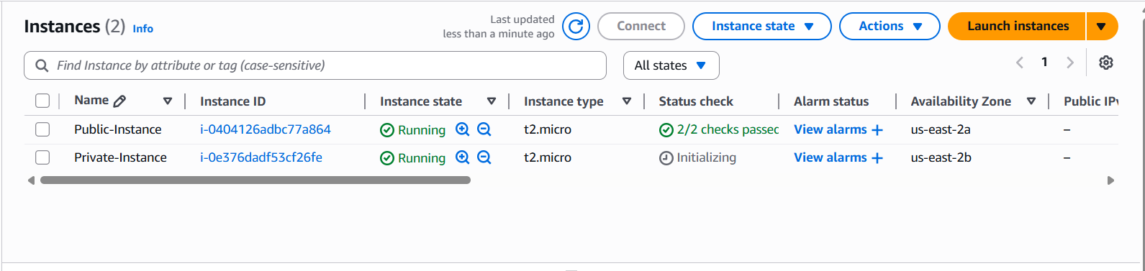
Fig: Two instances (Public-instance & Private-Instance) are created in both private & public subnets.
Step4: Create three endpoints (SSM, SSM-message, & ECE-message).
Go ToVPCEndpointsCreate endpointName tag (SSM)AWS-service com.amazonaws.us-east-2.ssm (search & select)select VPCselect subnetsselect security groupCreate endpoint.
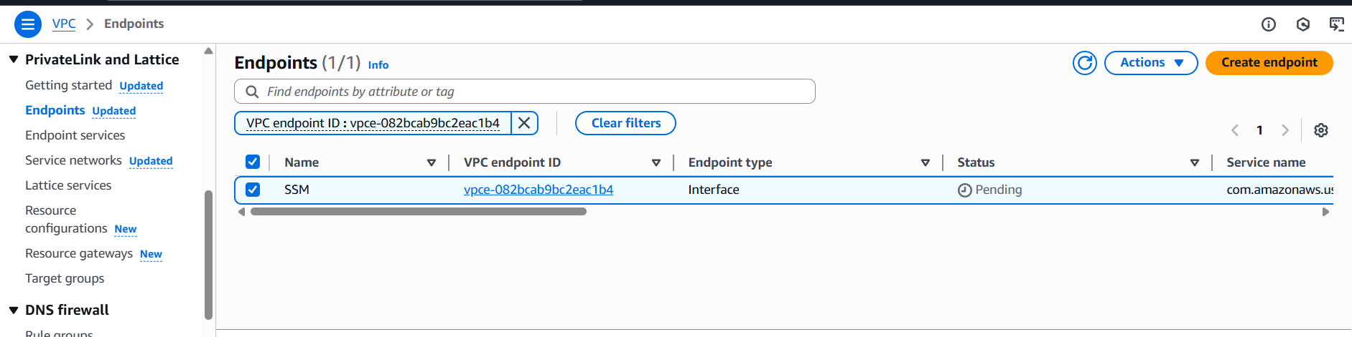
Fig: SSM endpoint is created.

Similarly create SSM-message (com.amazonaws.us-east-2.ssmmessages) & EC2-message (com.amazonaws.us-east-2.ec2messages) end points.

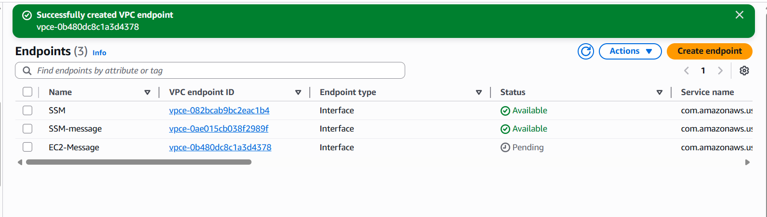
Fig: All three endpoints are created successfully.

Step5: Now we can see the instances (Private-instance & public-instance) in session manager and we can connect to them.
Go ToSSM (AWS System manager)session manager start session.
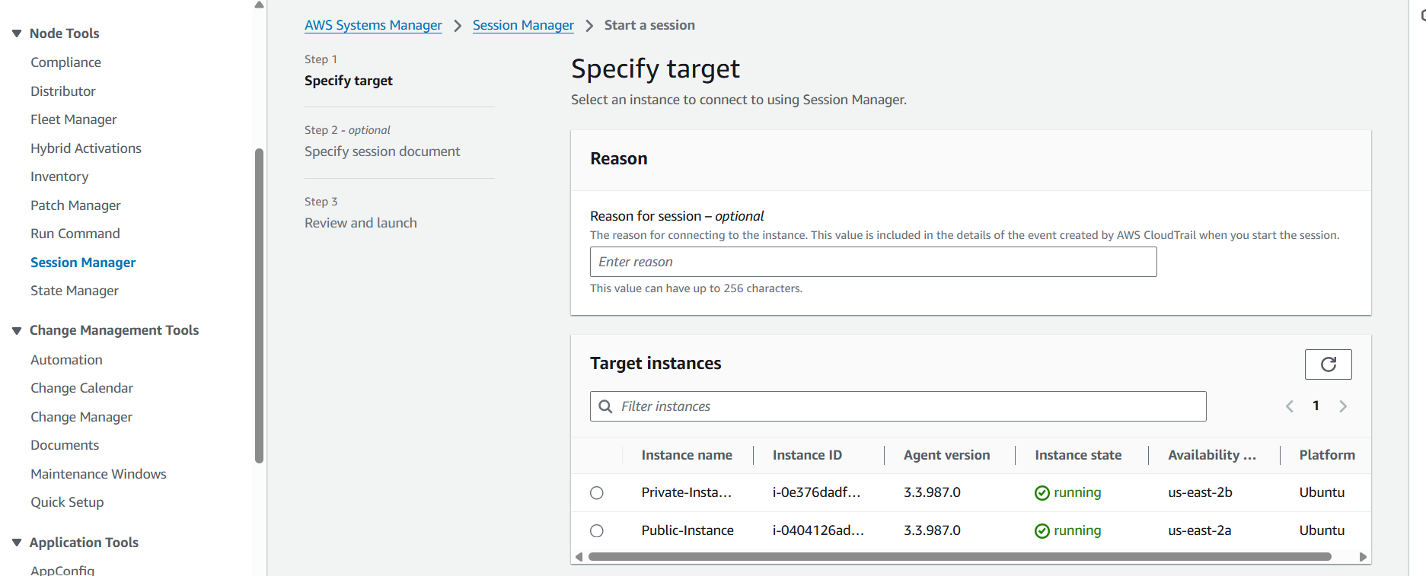
Fig: Two instances where appeared in the session manger after adding three endpoints.

Step6: Now we can connect to the instances using the session manager over the AWS internal network.
Go ToSSM (AWS System manager)session manager start sessionselect any target instancenextstart session.
It connects to the EC2 instance using AWS web console.
